

**DAYANANDA SAGAR UNIVERSITY**

**DEPARTMENT OF COMPUTER SCIENCE & ENGINEERING**

**ASSIGNMENT**

ON

“**DATABASE OF** **VmWARE**”

**BACHELOR OF TECHNOLOGY**

**IN**

**COMPUTER SCIENCE & ENGINEERING**

Submitted by

**BHOOMIKA G – ENG21CS0076**

**BHAMINI A V – ENG21CS0072**

**BHEEMKIRAN NADEKAR – ENG21CS0075**

**ADITYA S P -ENG21CS0017**

**V Semester, 2023**

**Course Code: 21CS3501**

**Course: Database Management System**

**INTRODUCTION**

VMware relies on databases as a foundational element in its virtualization and cloud computing solutions. These databases serve a multifaceted role, storing configuration settings, management data, and performance metrics crucial for efficiently overseeing virtualized environments. The vCenter Server database, integral to vSphere, centralizes information on inventory, resource pools, user permissions, and historical performance. Databases also store logs and audit trails for troubleshooting and security. Essential metadata about virtual machines, templates, and resource allocations are managed through databases, facilitating dynamic adjustments to computing resources. Historical performance data aids in trend analysis and capacity planning. Additionally, databases play a vital role in securing virtualized environments by storing information about user accounts, roles, and permissions. Overall, databases are fundamental to the seamless operation, management, and security of VMware's virtualization and cloud solutions.

1. **DATABASE USED BY VMware**
   1. **WHICH DATABASES?**

VMware supports multiple databases for different components of its software suite. The choice of database can depend on the specific VMware product or solution, as well as customer preferences. Here are some commonly used databases with VMware products:

*vCenter Server Database:*

Microsoft SQL Server

Oracle

PostgreSQL

*VMware Update Manager (VUM) Database:*

Microsoft SQL Server

Oracle

*vRealize Suite Databases:*

PostgreSQL

Microsoft SQL Server

Oracle

*VMware Identity Manager Database:*

PostgreSQL

Microsoft SQL Server

*Log Insight Database:*

PostgreSQL

* 1. **COMMONLY USED DATABASE BY VMware ECOSYSTEM**

PostgreSQL has become increasingly popular and is commonly used in the VMware ecosystem. It's often the default choice for certain VMware products, such as vCenter Server Appliance, owing to its open-source nature, ease of use, and robust performance.

Microsoft SQL Server and Oracle are also widely used, particularly in enterprise environments where these databases may already be established as part of the existing IT infrastructure.

1. **ARCHITECTURE**

**WORKING MODEL/ARCHITECTURE OF MYSQL**

MySQL is a Relational Database Management system which is free Open Source Software Under GNU License.

Architecture of MySQL describes the relation among the different components of MySQL System. MySQL follow Client-Server Architecture. It is designed so that end user that is Clients can access the resources from Computer that is server using various networking services. The Architecture of MY SQL contain following major layer’s:

* Client
* Server
* Storage Layer

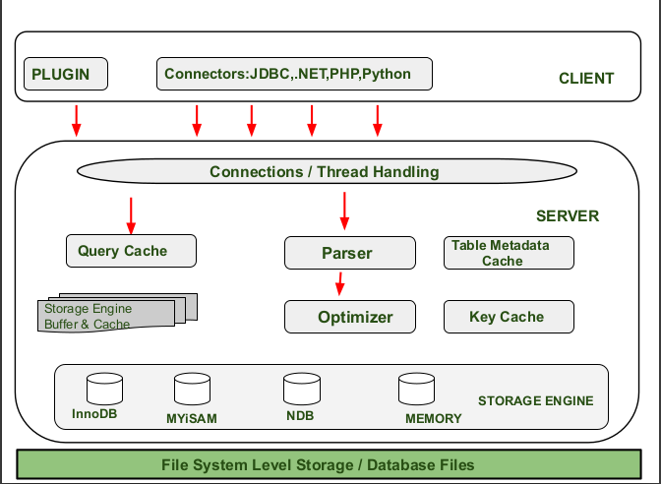

The Client Layer in MySQL manages user requests, including connection handling, authentication, and security, while the Server Layer acts as the "Brain" by handling logical functionalities like thread management, parsing, optimization, and caching, and the Storage Layer employs pluggable storage engines like InnoDB and MyISAM for diverse storage need

**VMware SQL with MySQL for Kubernetes Architecture**

This section illustrates the two topologies of MySQL instances:

Single-node instances

High-availablity (HA) instances

**Architecture of a Single-Node MySQL Instance**

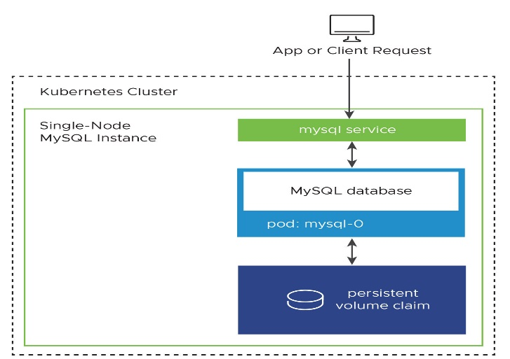

**Architecture of an HA MySQL Instance**

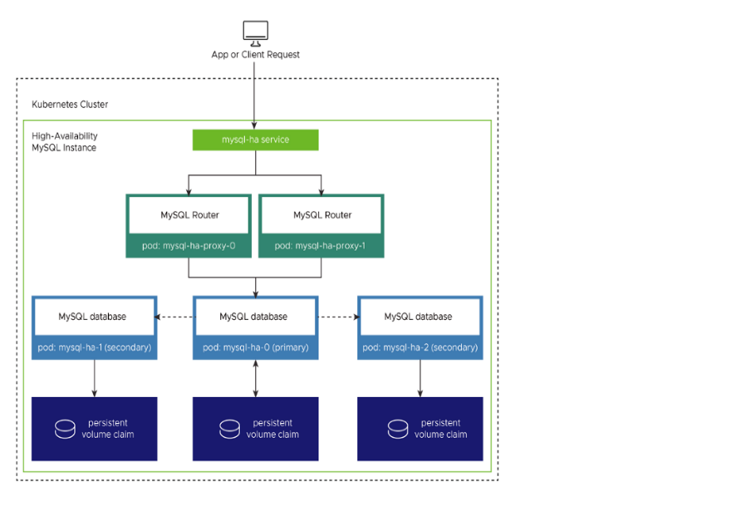

In a single-node MySQL instance, client requests are directed to the MySQL service, communicating with the database Pod storing data in a persistent volume claim; for high availability in a Kubernetes environment using VMware SQL with MySQL, InnoDB Cluster with Group Replication ensures failover among one primary and two secondary MySQL Pods, managed by proxy Pods, offering continuous operation and automatic recovery in the event of Pod failures

**WORKING MODEL/ARCHITECTURE OF POSTGRESQL**

PostgreSQL operates on a client-server model where clients initiate connections to the server to perform database operations, sending SQL queries or commands through a client interface. The server processes these requests, executes the required actions, and returns the results to the clients, ensuring concurrent access, security, and centralized control over the database.

Step 1:

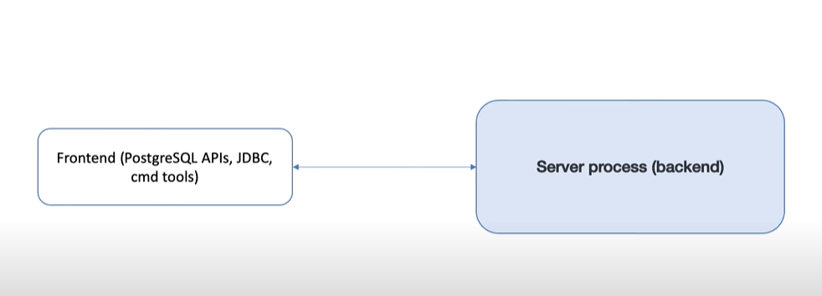

Step 2:

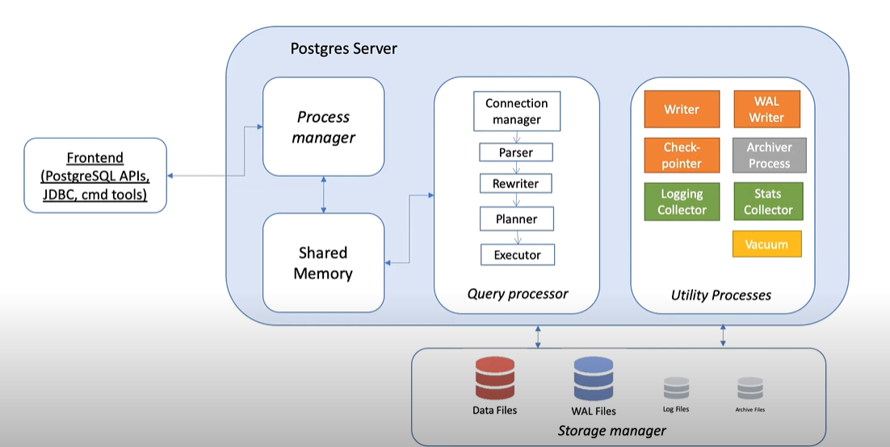

Step 3:

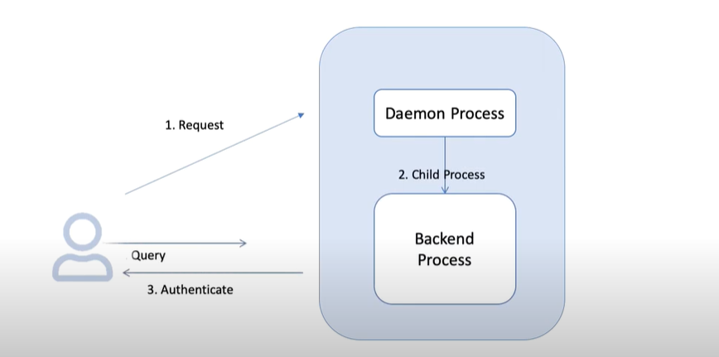

**POSTGRES IN KUBERNETES**

PostgreSQL in Kubernetes allows for the seamless orchestration and management of PostgreSQL database instances within containerized environments, providing scalability, flexibility, and simplified deployment

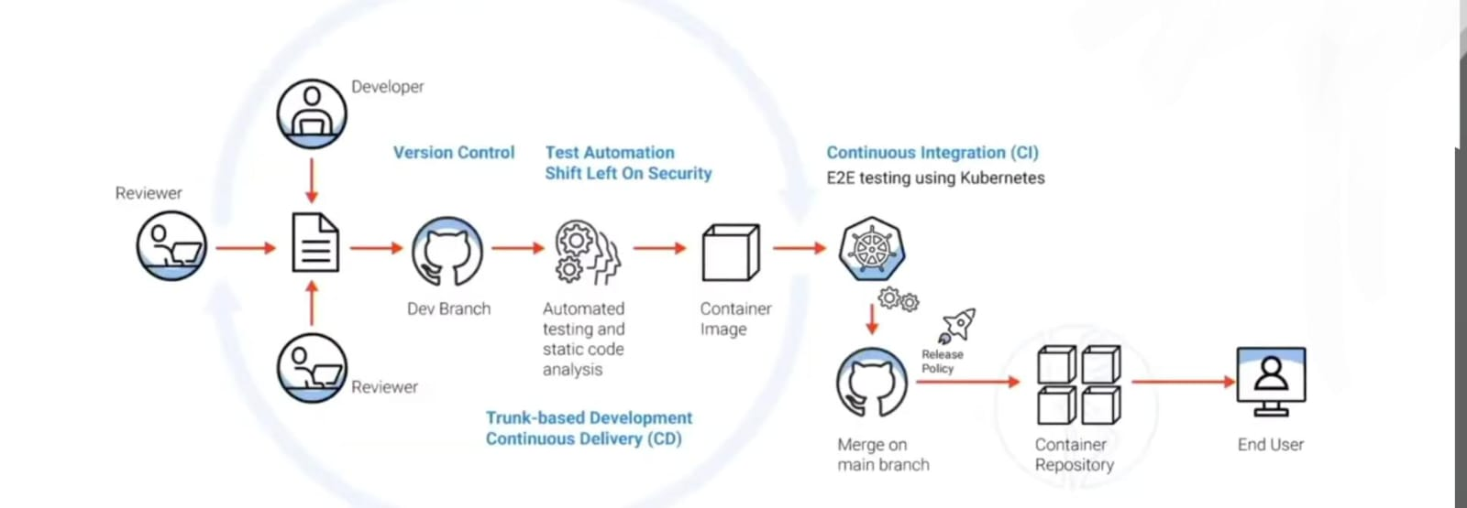

**FEATURES THAT MAKE IT UNIQUE APART FROM OTHER DATABASES**

It's crucial to understand that the choice of databases can vary depending on the specific VMware product and version. For instance, vCenter Server supports multiple databases, including Microsoft SQL Server and Oracle, in addition to PostgreSQL. The selection may also be influenced by historical factors, industry trends, and the evolving needs of VMware's user base**.**

* VMware products are designed to integrate seamlessly with certain databases. MySQL and PostgreSQL might align well with the requirements and integration capabilities of VMware solutions.
* Both MySQL and PostgreSQL are known for their performance. Depending on the workload and use case, these databases might meet the performance expectations of VMware products.
* Licensing models can influence the choice of databases. MySQL, for example, is dual-licensed, allowing for both open-source and commercial use.
* MySQL and PostgreSQL are open-source databases. VMware may opt for open-source solutions to align with its philosophy and to provide cost-effective options to users.

**COMMERCIAL OR OPEN SOURCE**

PostgreSQL is open source, while Microsoft SQL Server and Oracle are commercial databases with licensing costs associated with their full-featured versions.

MySQL Server

Commercial: MySQL Server has a commercial license, and while there are free editions with limited features (like SQL Server Express), the full-featured versions typically require a paid license.

PostgreSQL

Open Source: PostgreSQL is an open-source relational database management system released under the PostgreSQL License, which is a permissive free-software license.

**ADVANTAGES AND LIMITATIONS**

**MySQL:**

*Advantages:*

* Excellent integration with other Microsoft products and technologies.
* Robust business intelligence and reporting tools, such as SQL Server Reporting Services (SSRS).
* Native support for .NET development.
* Advanced security features, including integration with Active Directory.

*Limitations:*

* Licensing costs for full-featured editions can be relatively high.
* Limited cross-platform support compared to open-source databases.
* Some features may be more proprietary and less standardized.

**PostgreSQL:**

*Advantages:*

* Open-source and free, making it cost-effective.
* Extensible with support for custom data types and functions.
* Strong support for JSON and other modern data types.
* High level of standards compliance.

*Limitations:*

* May not have all the enterprise-level features found in commercial databases.
* Limited official support compared to commercial alternatives.
* Performance might vary depending on specific use cases.